LAB NO 2
TASK#1
Create a User
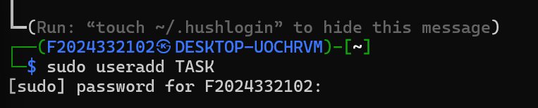
Command: sudo useradd TASK
Sudo runs the command with administrator so we can modify users, useradd tells linux to add a new user account. Task is the name of the new user.

Update the user:
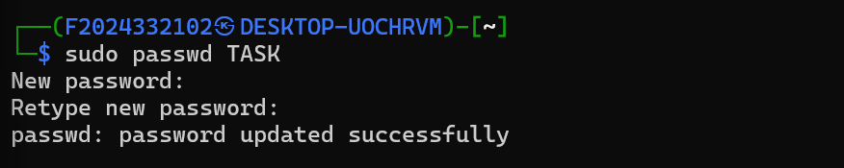
Commands:
- sudo passwd TASK
- sudo usermod -s /bin/bash NEW
passwd will update the previous password to new, usermod

Open linux task manager:
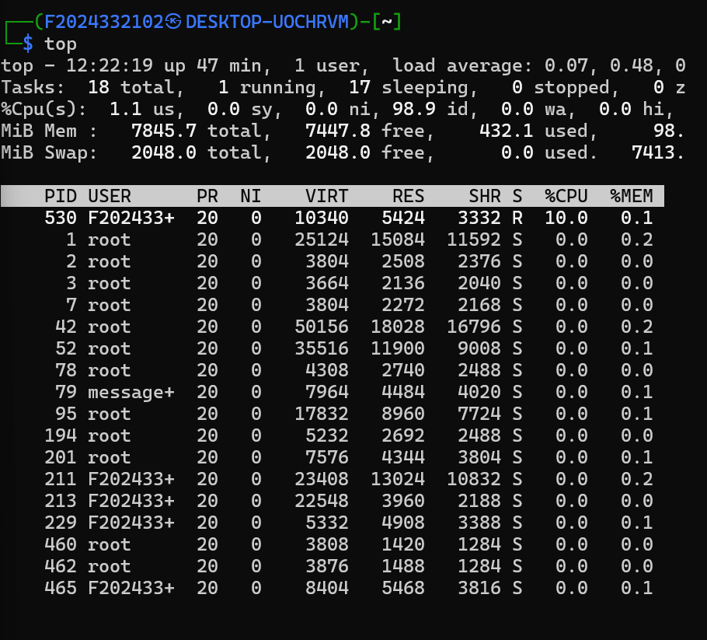
Command: Top
It opens task manager in linux from where the next task will be done

Kill a process:
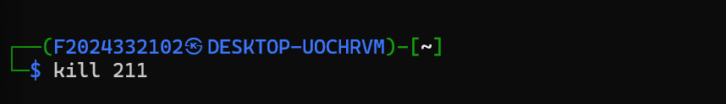
Command kill 211
Kills the process by identifying it from the id number which is unique to that task.

